**Unit: Manual Motor Controls Test: 2**

**Symbols and Boolean Logic CLO#: 1**

Name ______________________________ Date ______________

**Instructions**

Fill in the description and I/O columns for each NEMA schematic symbol below.

|  | Symbol | Description | I/O |
| --- | --- | --- | --- |
| 1 |  |  |  |
| 2 |  |  |  |
| 3 |  |  |  |
| 4 |  |  |  |
| 5 |  |  |  |
| 6 |  |  |  |

1. Select all of the correct terms used to describe the state of a component that is not wired within a circuit.
   1. Normal
   2. Shelf
   3. De-energized
   4. Closed
   5. Not working
2. When building a control circuit, there is not an industry standard on the order (inputs and outputs) of the components.
   1. True
   2. False
3. A component that is normally closed would have terminal numbers ____ and ____.
4. If a circuit has three inputs, in how many possible states can that circuit be placed?
5. When hand drawing a control schematic, wire numbers are denoted by using?
   1. Boxes
   2. Triangles
   3. Circles
   4. Underline
6. When hand drawing a control schematic, terminal numbers are denoted by using?
   1. Boxes
   2. Triangles
   3. Circles
   4. Underline

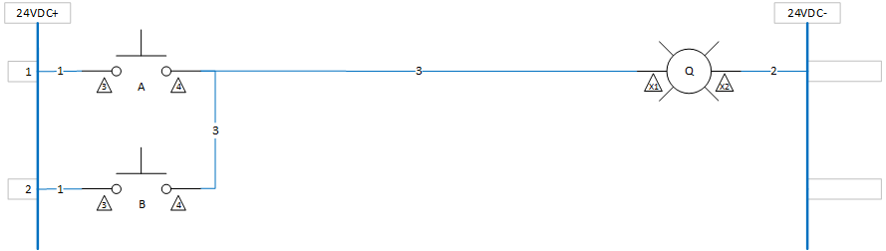

1. Draw a truth table for the above circuit.
2. Enter the formula for this circuit.
3. How would you describe this circuit?
   1. EQUAL Logic
   2. NOT Logic
   3. AND Logic
   4. OR Logic